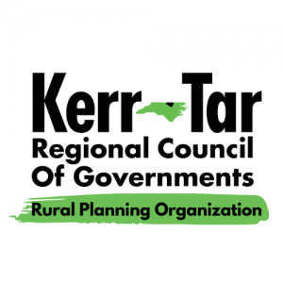

**Kerr-Tar RPO TCC and TAC Meeting**

*Wednesday, February 26, 2025*

*3:00PM – 4:00PM*

*This will be a hybrid in-person/virtual meeting. All committee members should join the meeting using Zoom if attending virtually, or attend in-person. Members of the public may attend in-person.*

***ZOOM***: <https://us02web.zoom.us/j/9044459273?pwd=Qm24U5XavaWvaD8eQmaZuSmrwls3Ka.1&omn=81346650899>

*Meeting ID: 904 445 9273*

*Passcode: 0523*

*Phone: +1 301 715 8592 US*

1. **Roll Call to Establish Quorum**

Establish quorum for Transportation Advisory Committee (TAC) Ty Cheek

Establish quorum for Technical Coordinating Committee (TCC) Ty Cheek

1. **Call to Order**

TCC call to order Chairman Baker

TAC call to order Chairman Lane

1. **Ethics Awareness and Conflict of Interest Reminder**

Pursuant to NCGS §138A-15 (e): Does any member have any known conflict of interest with respect to any matters coming before the board today? If so, please identify the conflict and refrain from any participation in the particular matter involved.

1. **Public Comments**

This is the time set aside by the TAC Board to allow individuals to address the Board on issues concerning the RPO. The time limit for each speaker shall be five minutes with a total time limit set aside for informal public comments totaling 30 minutes. Vulgarity and abusive comments will not be tolerated.

1. **Item for Presentation –**

Approval of Proposed 2025 Meeting Schedule Ty Cheek, Regional Transportation Planner

Approval for the removal of BN-0013 from the STIP

1. **Items for TAC/TCC Approval**

Proposed 2025 Meeting Schedule

Removal of BN-0013 from STIP

**7. NCDOT Division 5 Updates and Maintenance Reports**

**8.** **Informational Items –** Kerr-Tar RPO Staff

Prioritization 7.0 – Project Status

SRTS Update

Reminder of Ethics submissions – Submit by **April 15th**

Funding Opportunities:

2025 Clean Fuel Advanced Technology (CFAT) – March 10th

Special Events:

Open Discussion

**8. Member Updates from Around the Region/Open Discussion**

**9. Adjournment**

Motion to Adjourn by TCC and TAC

Next Regular Meeting – March 20th 2025