4041448Kerr-Tar Regional Transportation Planning Organization
P8.0 Local Input Methodology

INTRODUCTION
The Strategic Transportation Investments (STI) law (GS 136-189.10 and .11), enacted in 2013, directs NCDOT to select and fund major capital improvement projects using a data-driven prioritization process in combination with local input. Under STI, all major capital mobility/expansion and modernization projects across all six modes of transportation compete for funding. Each project is classified into one of three funding categories – Statewide Mobility, Regional Impact, or Division Needs – where it competes for funds with other eligible projects.

Statewide Mobility eligible projects compete against all other projects in this category across the state, and project selection is based 100% on the data-driven quantitative score. Regional Impact projects compete against all other projects in this category within the same funding region (consisting of two NCDOT Transportation Divisions), and selection is based 70% on the quantitative score and 30% on local input (15% MPO/RPO priority and 15% NCDOT Division Engineer priority). Division Needs projects compete against all other projects within the same NCDOT Transportation Division, and selection is based 50% on quantitative score and 50% on local input (25% MPO/RPO priority and 25% NCDOT Division Engineer priority).

The STI law includes an innovative component known as cascading, where projects not funded in the Statewide Mobility category are eligible for funding in the Regional Impact category. Similarly, projects not funded in the Regional Impact category are eligible for Division Needs funds. Projects that cascade down are then subject to the scoring criteria and local input for the respective funding category.
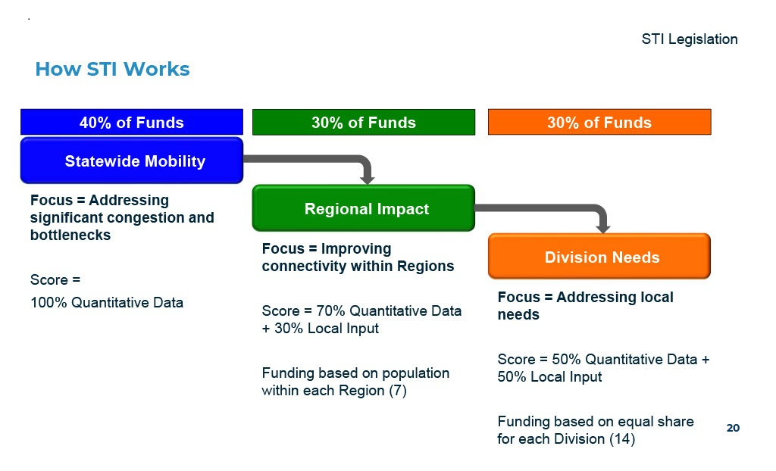
Project eligibility for each STI category, as defined in law, is illustrated below:

STI Project Eligibility
Mode | Statewide Mobility | Regional Impact | Division Needs
Highway | - Interstates (existing & future)  - NHS routes (as of July 1, 2013)  - STRAHNET Routes  - Designated Toll Facilities | Other US and NC Routes | - All Secondary Roads (SR)  - Federal-Aid Eligible Local Roads
Aviation | Large Commercial Service Airports | Other Commercial Service Airports not in Statewide | All Airports without Commercial Service (General Aviation)
Bicycle-Pedestrian | N/A | N/A | All projects ($0 state funds)
Public Transportation | N/A | Service spanning two or more counties | All other service, including terminals, stations, and facilities
Ferry | N/A | Vessel or infrastructure expansion | Replacement vessels
Rail | Freight Capacity Service on Class I Railroad Corridors | Rail service spanning two or more counties not Statewide | All other service, including terminals and stations (no short lines)

MPOs/RPOs and Divisions indicate priority by applying local input points to projects. Each organization receives a baseline of 1,000 local input points, with additional points (up to 2,500) based on population. The Kerr-Tar RPO has a total of 1400 points to apply to projects in the Regional Impact category and a total of 1400 points to apply to projects in the Division Needs category. State law requires NCDOT to approve how each organization will assign points to projects, in a document known as their Local Input Point Methodology.

Applicability: This process applies to all projects ranked by Kerr-Tar RPO in Person, Granville, Vance, Warren, or Franklin Counties that are ranked as “regional” or “division” funding level projects. Funding levels are defined in the Strategic Transportation Investments (STI) Act.

DESCRIPTION OF CRITERIA AND WEIGHTS:

The KTRPO has developed this prioritization method in an effort to satisfy the quantitative, data-driven requirements of the legislation while protecting the discretion of local officials by incorporating subjective qualitative local input where possible.

Following are the descriptions of the criteria the Kerr-Tar Rural Planning Organization will be using to score projects in the Regional Impact and Division Needs categories.

Project Ranking: Projects will be scored based on the criteria established, regardless of the eligible funding category (statewide, regional or division) and then separated by eligible funding categories into Regional and Division Level projects.

- Statewide Projects: Entirely determined by quantitative score. The statewide routes in KTRPO are US1, US158 and I-85. Any project that scores well enough will be removed from the process before KTRPO assigns local input points. All other routes will be included in the Regional level process.

- Regional Level Projects: US501, US15, US401, all NC routes, and Kerr Area Regional Transportation System (KARTS) are evaluated on the Regional Level.

- Division Level Projects: Projects involving SR routes, bicycle and pedestrian, Person Area Transportation System (PATS) transit, and two airports are evaluated at the Division Level.

Regional Impact Category Scoring
CRITERIA | MAX SCORE | POINTS ALLOCATED TOWARD REGIONAL IMPACT SCORE
Quantitative Score – Regional | 40 | Under 40 – 20pts |  | Over 40 – 40 pts
Destinations served | 30 | Zero destinations served – 0 points | Direct access to at least one destination – 20 points |  |  | Direct access to two ore mote destinations – 30 points
Local Priority | 20 | Priority #4  5 points | Priority #3  10 points |  | Priority #2  15 points |  | Priority #1  20 points
Plan Consistency | 5 | Project is not in a locally adopted plan  0 points |  |  |  |  | Project is in a locally adopted plan  5 points
Project Development | 5 | Feasibility Study or Express Design completed within 10 years  2 points | Sibling project is programmed in current STIP  3 points |  | Project is programmed (but not committed) in current STIP  4 points |  | Environmental document complete  5 points
Total | 100

*ANY PROJECTS NOT SELECTED FOR REGIONAL MAY QUALIFY FOR THE DIVISIONAL ROUND. HIGHWAY PROJECTS WILL* BE SCORED UNDER THE SAME CRITERIA AS BIKEPED & TRANSIT PROJECTS

Division Needs Category Scoring – BikePed & Transit
CRITERIA | MAX SCORE | POINTS ALLOCATED TOWARD DIVISION NEEDS SCORE
Quantitative Score - Division | 30 | Less than 25  15 points |  |  | 25 or more  30 points
Project expands capacity/ established access to at least one destination served / Enhances the ability of passengers to utilize service/ Project improves passenger safety / Project addresses a regional goal or objective | 20 | At least one of the criteria are met  5 points |  | 2 of the criteria met  10 points |  | 3 or more criteria met  20 points
Local Priority | 40 | Priority #4  10 points | Priority #3  20 points |  | Priority #2  30 points |  | Priority #1  40 points
Plan Consistency | 5 | Project is not in a locally adopted plan  0 points |  |  |  |  | Project is in a locally adopted plan  5 points
Project Development | 5 | Feasibility Study or Express Design completed within 10 years  2 points | Sibling project is programmed in current STIP  3 points |  | Project is programmed (but not committed) in current STIP  4 points |  | Environmental document complete  5 points
Total | 100

Division Needs Category Scoring - Rail & Aviation
CRITERIA | MAX SCORE | POINTS ALLOCATED TOWARD DIVISION NEEDS SCORE
Quantitative Score - Division | 30 | Less than 25  15 points |  |  | 25 or more  30 points
Project expands capacity/ established access to at least one destination served/ Project addresses an identified facility safety issue/ Project addresses a regional goal or objective | 20 | At least one of the criteria are met  5 points |  | 2 of the criteria met  10 points |  | 3 or more criteria met  20 points
Local Priority | 40 | Priority #4  10 points | Priority #3  20 points |  | Priority #2  30 points |  | Priority #1  40 points
Plan Consistency | 5 | Project is not in a locally adopted plan  0 points |  |  |  |  | Project is in a locally adopted plan  5 points
Project Development | 5 | Feasibility Study or Express Design completed within 10 years  2 points | Sibling project is programmed in current STIP  3 points |  | Project is programmed (but not committed) in current STIP  4 points |  | Environmental document complete  5 points
Total | 100

Criteria Definitions:

- Transportation plan consistency - Is the proposed project part of an existing, adopted transportation plan?
- Destination served - Does the project connect directly to an educational facility (such as elementary/middle school, high school, or community college), health care facility (such as hospitals or community clinics), employment (such as factories or industry) or recreation/entertainment destination (such as theatre, convention center or arena)?
- Project addresses a regional goal / objective - Includes: Comprehensive Economic Development Strategy (CEDS); Public Health Plan; Safe Routes to School Plan; Jobs Access and Mobility Objective, county specific economic development plans/objectives; local area plans; local economic development plans.
- Project addresses an identified facility safety Issue - These include, but are not limited to, improvements to track or runway condition, lighting, warning signalization, railroad crossings, control tower improvement.
- Project expands facility capacity - May include new or expanded runway, terminals, rail sidings, or additional track among other capacity-related improvements.
- Project expands capacity - Projects may include transit shelters, information systems, and/or new vehicles to support new or expanded routes.
- Enhances the ability of passengers to utilize service - Projects may include transit shelters, information systems, and/or new vehicles to support new or expanded routes.
- Project improves passenger safety - Will the project enhance on-board and/or passenger safety generally?

Total Score and Project Ranking:
Kerr-Tar RPO receives 1,400 points at the Regional Level and 1,400 points at the Division Level to allocate to projects for local prioritization. The maximum number of points any project can receive is 100.

KTRPO staff will use the following process to create a pool of the top projects from across all tiers. KTRPO will then filter out projects into separate lists by tier. To rank all projects, staff will add together the P8 quantitative score as calculated by NCDOT and the score from the ranking process outlined on the next several pages. Final projects scores will reflect the following per STI, enabling legislation by the North Carolina General Assembly.

POINTS ASSIGNMENT PROCESS

The top two projects in each county from the Regional list will be assigned 100 points for a total of 1,000 points. Four more projects will come from the next highest ranked projects regardless of county. Those projects will also be assigned 100 points each for a total of 1,400 points.

Only projects that originate at the Statewide or Regional Level are eligible for scoring and local points allocation under this methodology.

The same process will be used for the Division level with the exception that at least one of the ranked projects on the draft Division Ranked Priority list must be non-highway mode.

Only projects that originate at the Regional or Division Level are eligible for scoring and local points allocation under this methodology.

Final Ranking and Local Points Assignment: The TAC and TCC will consider the public comments. They will be able to make changes to the draft Ranked Priority lists at the Regional and Division level where they can decide to delete up to two (2) projects in each list and replace them with projects from the project lists or, donate the points to a project outside of KTRPO.

The TAC is free to deviate from the preliminary points assignment when making the final point assignments to compensate for situations where the methodology does not accurately reflect the TAC’s priorities and to ensure appropriate projects at the relevant category. Any variation in point assignments from the preliminary point assignments must have justifications documented in the meeting minutes and posted on the Kerr-Tar Regional Council of Governments website. Anticipated justifications include but are not limited to project cost, point-sharing arrangements, estimated points required for funding, geographic equity, modal distribution, new information and public comment.

Policy addressing project split across another MPO/RPO and left over points: In the event that extra points are left over if a project falls partially into another MPO/RPO, these remaining points may be donated to the MPO/RPO to assign points on behalf of KTRPO. If the MPO/RPO has also set aside points for the project, the points may be allocated to the next highest KTRPO project to help boost its score. If this project has received the maximum number of points, the remaining points will go down the line to the next available project that has not received the maximum number of points.

PUBLIC INPUT CONSIDERATION

Use of Public Input and Comments in Final Methodologies and Rankings: The TAC will review all public comment received. Public comments will be documented, filed by the RPO, and distributed to appropriate local entities to inform future Prioritization processes and transportation plans. No new projects will be added to the current Prioritization 8.0 list; however, as the NCDOT deadline for submitting new projects will have passed.

SCHEDULE OF PUBLIC OUTREACH

Local Methodology: KTRPO will release the methodology for a 30-day public comment period. This 30-day period will be advertised on Kerr-Tar Regional Council of Governments’ website (www.kerrtarcog.org), a process conducted in accordance with KTRPO’s Public Involvement Plan. The results of the public comment period will be presented to the TAC for final approval. All public comments will be documented, and reasonable edits to the methodology may be made prior to final approval by the TAC, and submission to the Strategic Prioritization Office of Transportation.

The RPO will present the recommended local points assignments and total scores of all projects to the TCC and TAC at a meeting before the NCDOT deadlines. Upon approval of the TAC, the RPO will release the recommended projects and points assignments for a 30-day public comment period. This 30-day period will be advertised on the Kerr-Tar Regional Council of Governments’ website and all relevant documents will be available on the website. The process will be conducted in accordance with KTRPO’s Public Involvement Plan. All public comment will be documented.

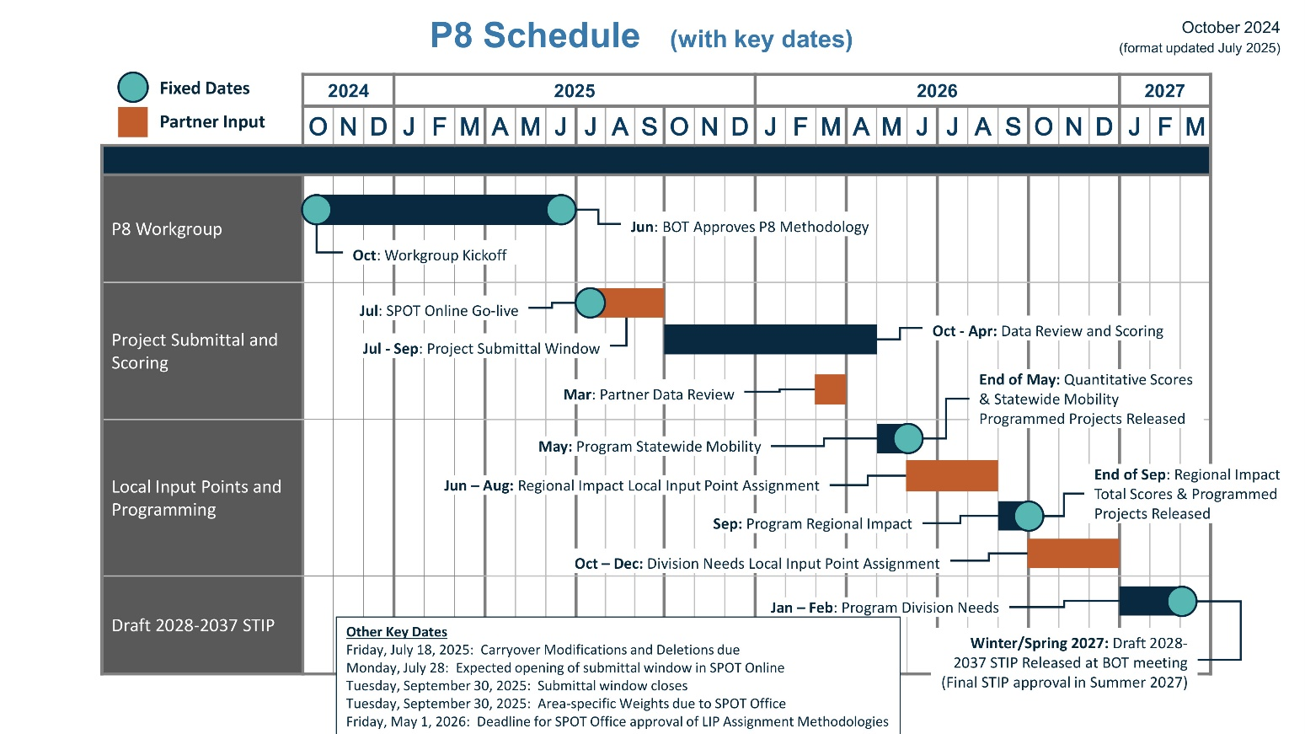

MATERIAL SHARING
Materials will be provided on the Kerr-Tar Regional Council of Governments’ website at https://www.kerrtarcog.org/ and will include: 1) A link to the NCDOT STI Prioritization Resources website; 2) The adopted Kerr-Tar RPO Prioritization 8.0 Methodology document and 3) Regional Impact and Division Needs local impact points assignment documentation. All materials will be posted until adoption of the final STIP by the NCDOT Board of Transportation

Adoption

A motion was made by Roxanne Bragg and seconded by Walter Gardner for the adoption of the Kerr-Tar Regional Transportation Planning Organization’s P7.0 Local Input Methodology, and upon being put to a vote was duly adopted on March 28, 2024.

______________________________________ ______________________________________
Tom Lane Diane Cox
TAC Chairman Secretary, Kerr-Tar RPO

