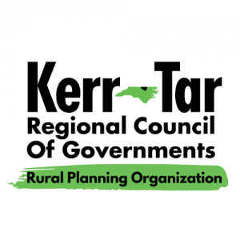

**Kerr-Tar RPO TCC and TAC Meeting**

*Thursday, August 22, 2024*

*3:00PM – 4:00PM*

*This will be a hybrid in-person/virtual meeting. All committee members should join the meeting using Zoom if attending virtually, or attend in-person. Members of the public may attend in-person.*

*ZOOM:* <https://us02web.zoom.us/j/83438917177?pwd=8CD46fRO7nWIZIKBxOEfBerrsicDMs.1>

*Meeting ID: 834 3891 7177*

*Passcode: 803986*

*Phone: +1 301 715 8592 US*

1. **Roll Call to Establish Quorum**

Establish quorum for Transportation Advisory Committee (TAC) Ty Cheek

Establish quorum for Technical Coordinating Committee (TCC) Ty Cheek

1. **Call to Order**

TCC call to order Chairman Baker

TAC call to order Chairman Lane

1. **Ethics Awareness and Conflict of Interest Reminder**

Pursuant to NCGS §138A-15 (e): Does any member have any known conflict of interest with respect to any matters coming before the board today? If so, please identify the conflict and refrain from any participation in the particular matter involved.

1. **Public Comments**

This is the time set aside by the TAC Board to allow individuals to address the Board on issues concerning the RPO. The time limit for each speaker shall be five minutes with a total time limit set aside for informal public comments totaling 30 minutes. Vulgarity and abusive comments will not be tolerated.

1. **Item for Presentation –**

Open Discussion of Regional Local Input Points Ty Cheek, Regional Transportation Planner

1. **Items for TAC/TCC Approval**

Minutes from 5/23/2024 Meeting

Local Input Points (LIP)

**7. NCDOT Division 5 Updates and Maintenance Reports**

**8.** **Informational Items –** Kerr-Tar RPO Staff

Prioritization 7.0 – Project Status

SRTS Update

Funding Opportunities:

CMAQ and CRP - March 31, June 30, September 30, and December 31

Recreational Trails Program Grant – September 6, 2024

Special Events:

Fall Litter Sweep - As the leaves begin to turn, the N.C. Department of Transportation is excited to announce its Fall Litter Sweep from Sept. 14-28.

13th Annual Bikewalk NC Transportation Summit – Sept. 22-24

**8. Member Updates from Around the Region/Open Discussion**

**9. Adjournment**

Motion to Adjourn by TCC and TAC

Next Regular Meeting – October 24, 2024