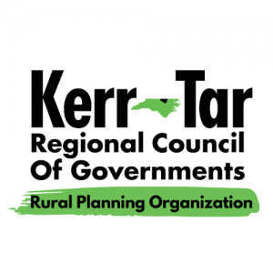

**Kerr-Tar RPO TCC and TAC Meeting**

*Thursday, November 21, 2024*

*3:00PM – 4:00PM*

*This will be a hybrid in-person/virtual meeting. All committee members should join the meeting using Zoom if attending virtually, or attend in-person. Members of the public may attend in-person.*

***ZOOM***<https://us02web.zoom.us/j/88342938164?pwd=QTZB0yXrlB3K63w3gSQiiguhrCTqXl.1>

*Meeting ID: 883 4293 8164*

*Passcode: 572519*

*Phone: +1 301 715 8592 US*

1. **Roll Call to Establish Quorum**

Establish quorum for Transportation Advisory Committee (TAC) Ty Cheek

Establish quorum for Technical Coordinating Committee (TCC) Ty Cheek

1. **Call to Order**

TCC call to order Chairman Baker

TAC call to order Chairman Lane

1. **Ethics Awareness and Conflict of Interest Reminder**

Pursuant to NCGS §138A-15 (e): Does any member have any known conflict of interest with respect to any matters coming before the board today? If so, please identify the conflict and refrain from any participation in the particular matter involved.

1. **Public Comments**

This is the time set aside by the TAC Board to allow individuals to address the Board on issues concerning the RPO. The time limit for each speaker shall be five minutes with a total time limit set aside for informal public comments totaling 30 minutes. Vulgarity and abusive comments will not be tolerated.

1. **Item for Presentation –**

Open Discussion of Divisional Local Input Points Ty Cheek, Regional Transportation Planner

1. **Items for TAC/TCC Approval**

Minutes from 8/22/2024 Meeting

Divisional Local Input Points (LIP)

**7. NCDOT Division 5 Updates and Maintenance Reports**

**8.** **Informational Items –** Kerr-Tar RPO Staff

Prioritization 7.0 – Project Status

SRTS Update

Funding Opportunities:

CMAQ and CRP - March 31, June 30, September 30, and December 31

Special Events:

Open Discussion

**8. Member Updates from Around the Region/Open Discussion**

**9. Adjournment**

Motion to Adjourn by TCC and TAC

Next Regular Meeting – TBA in 2025